
HDSC31D-4K
3-Input DisplayPort, HDMI & VGA Collaboration Switcher Scaler over HDBaseT™
Switch & Scale Three inputs over CAT6 up to 230 feet (70m)
All Rights Reserved
Version: HDSC31D-4K_2016V1.0
User manual

Thank you for purchasing this product. For optimum performance and safety, please read the instruction carefully before connecting, operating or fine-tuning this product. Keep this manual for future reference.
Please note:
We recommend using CAT5e/6 shielded Twisted pair cable for the Tx and Rx
Using the TIA/EIA-568-B cable termination method.
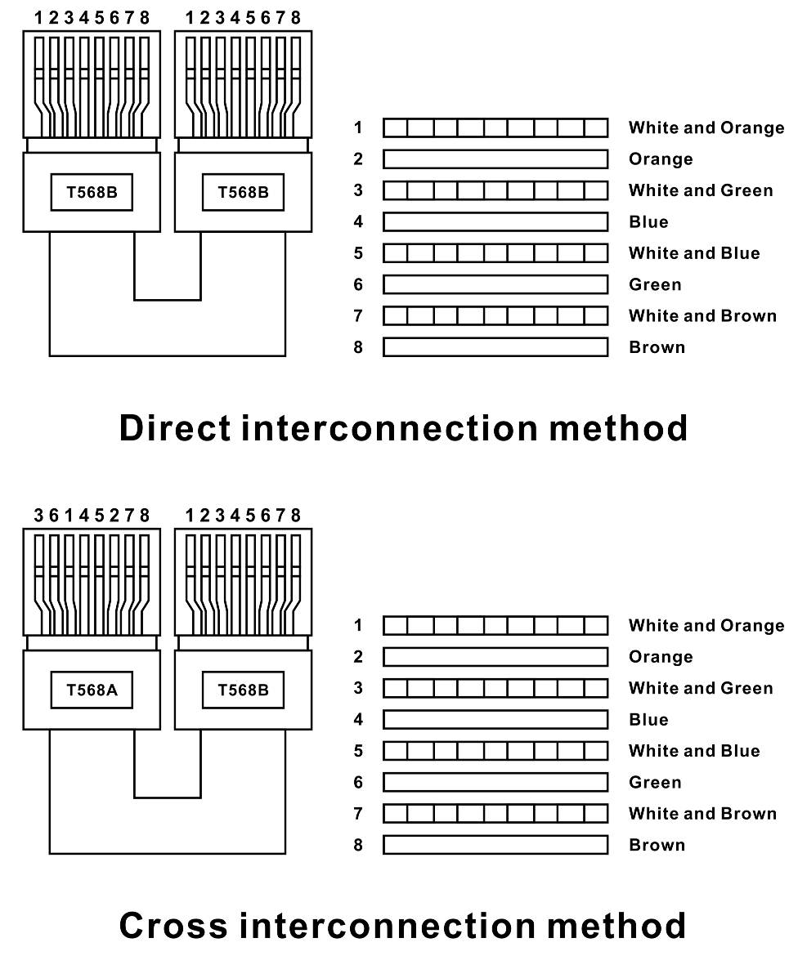
Advanced:
The extender will be in Automatic protection mode when using STP cable termination following the standard of TIA/EIA-568-A.

I. Intro to HDSC31D-4K
The KanexPro HDSC31D-4K is a three input Collaboration Switcher Scaler designed for sending DisplayPort, HDMI, or VGA - analog video and control up to 230 feet (70 meters) over a shielded CATx cable to an HDBaseT™ receiver supporting resolutions up to 4K/30Hz. The sender or receiver can be powered from either sides requiring only one power supply supporting POE (Power over Ethernet) and allowing you to switch between the sources and up-scale or downscale to desired video resolutions.

II. Features
- 3-input Collaboration Switcher & Scaler w/ HDBaseT
- Reliable switching with selectable output resolutions up to 4K@30Hz
- Transmission distance: Over CAT6 cable:
- 70 meters: 1080p@60Hz36bit; 3D1080p@30Hz36bit;
- 40 meters: 1080p @60Hz@48bit; 1080p @120Hz@24bit;
- 3D, 1080p@60Hz@36bit; 4K x 2K@30Hz@24bit.
- VGA supports scaling resolutions up to 1600x1200@60Hz
- HDBaseT routing distance over STP CATx up to 230 feet (70m)
- Bi-directional POE support (Tx to Rx or Rx to Tx)
- Bi-directional IR control, front-panel & RS-232 pass thru
- Supports CEC & HDCP 2.2 compliant
- Locking power supplies
- Compact & slim design for flexible installation
- Includes mounting kits
- Transfer Bidirectional Infra-red control signal together with the HDMI signal.
See description 2.
- Transfer Bi-directional RS232 control signal together with the HDMI signal.
See the description 3.
Basic RS-232 commands:
- Baud Rate: 9600
- Data Width: 8 bit
- Parity: None
- Stop: 1bit

      - Port switch command package length is 13 byte:
[0xa5+0x5b+0x16+0x01+input port(1~3)+0x00+0x00+0x00+0x00+0x00+0x00+0x00+checksum]
All you need to change is just “input port”, “checksum”
Checksum+(0xa5+0x5b+0x16+0x01+input port(1~3)+0x00+0x00+0x00+0x00+0x00+0x00+0x00)=0
For example: Set input 1 command
A5 5B 16 01 01 00 00 00 00 00 00 00 E8
Set input 2 command:
A5 5B 16 01 02 00 00 00 00 00 00 00 E7
Set input3 command
A5 5B 16 01 03 00 00 00 00 00 00 00 E6

      - Resolution switch command package length is 13 byte:
[0xa5+0x5b+0x19+0x01+ resolution +0x00+0x00+0x00+0x00+0x00+0x00+0x00+checksum]
For example: set resolution (1=1080p, 2=720p) command:
A5 5B 19 01 01 00 00 00 00 00 00 00 E5

III. Package contents
- HDBaseT Extender Transmitter ------------------------------------------ 1PC
- HDBaseT Extender Receiver ---------------------------------------------- 1PC
- Wideband IR Tx -------------------------------------------------------------- 2PCS
- Wideband IR Rx -------------------------------------------------------------- 2PCS
- 24V, 1A DC Power Supply --------------------------------------------------- 1PC
- Operation Manual ------------------------------------------------------------ 1PC
- Mounting ears-----------------------------------------------------------------4PCS
IV. Specifications
- Frequency Bandwidth 297MHz[10.2Gbps]
- Power Supply DC 24V 1A
- ESD Protection ± 8kV (air-gap discharge)
Human Body Model: ± 4kV (contact discharge)
- Dimensions (mm) TX: 75(W) X 193 (D) X 17.5 (H)
RX: 75(W) X 145 (D) X 17.5 (H)
- Weight TX: 380g RX: 290g
- Operating Temperature 0°C ~ 40°C / 32°F ~ 104°F
- Storage Temperature -20°C ~ 60°C / -4°F ~ 140°F
- Relative Humidity 20~90% RH (Non-condensing)
- Power Consumption (Max) 20W

V. Operation controls and Functions
Transmitter (Tx)
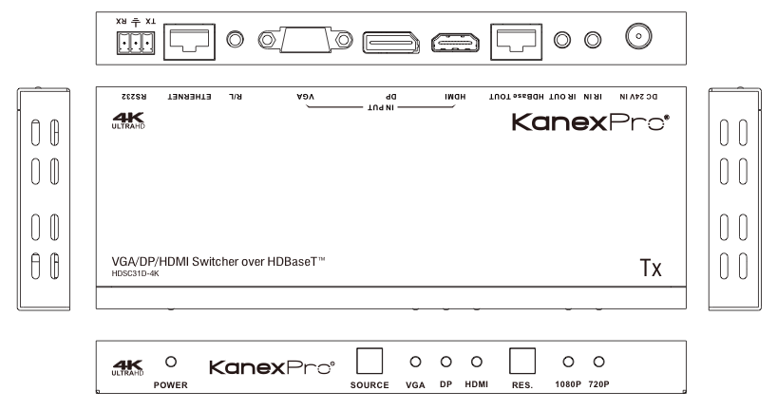

- POWER: This LED will illuminate when the power is on.
- SOURCE: Press the button to select the input source, and the LED will indicates the corresponding input source.
- RESOLUTION: Press the button to select the output resolution, and the LED will indicate the corresponding resolution.
- DC 24V: Plug the 24V DC power supply into the unit.
- IR IN: Channel 2 IR Receiver. Connect with Wideband IR Rx.
- IR OUT: Channel 1 IR Transmitter. Connect with Wideband IR Tx.
- HDBaseT OUT: Standard HDBaseT signal output port. Connect HDBaseT receiver with a UTP cable following the standard of TIA/EIA-568-B.
Green link LED: The connection status-indicating LED.
※Illuminate: Transmitter and Receiver well connected.
※Flashing: Transmitter and Receiver poorly connected.
※Dark: Transmitter and Receiver not connected properly.
Yellow data LED: The data status-indicating LED.
※Illuminate: HDMI signal with HDCP.
※Flashing: HDMI signal without HDCP or unauthorized content.
※Black or dark: No HDMI signal.
- HDMI IN: HDMI input port. This port is where you connect the HDMI source.
- DP IN: DisplayPort input port. This port is where you connect the DP source.
- VGA IN: VGA input port. This port is where you connect the VGA source.
- RS-232: Phoenix connectors provide Serial port control signal from transmitter or to the transmitter.

Receiver (Rx)

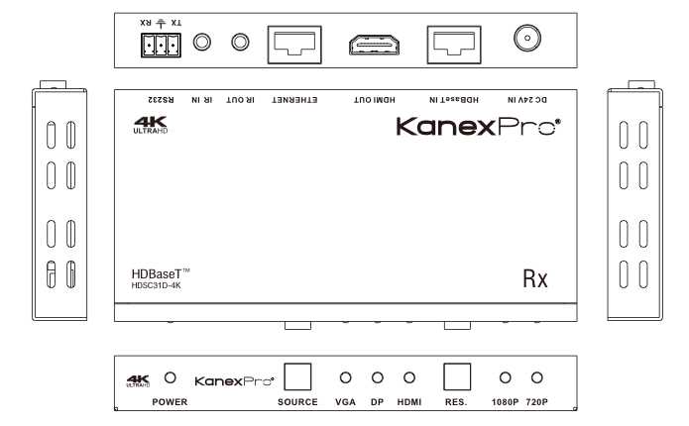

- POWER: This LED will illuminate when the power is on.
- SOURCE: Press this button to select the input source, and the LED will indicate the corresponding input source.
- RESOLUTION: Press this button to select the output resolution, and the LED will indicate the corresponding resolution.
- DC 24V: Plug the 24V DC power supply into the either of the Tx or Rx.
- HDBaseT IN: Standard HDBaseT signal input port. Connect HDBaseT transmitter with a STP cable following the standard of TIA/EIA-568-B.
Green link LED: The connection status-indicating LED.
- Illuminate: Transmitter and Receiver well connected.
- Flashing: Transmitter and Receiver poorly connected.
- Black or Dark: Transmitter and Receiver no connected.
Yellow data LED: The data status-indicating LED.
- Illuminate: HDMI signal with HDCP.
- Flashing: HDMI signal without HDCP.
- Black or Dark: No HDMI signal.
- HDMI OUT: HDMI output port. This port is where you connect the HDTV or monitor with HDMI cable.
- IR IN: Channel 2x IR Receiver. Connect with Wideband IR Rx.
- IR OUT: Channel 1x IR Transmitter. Connect with Wideband IR Tx.
- RS-232: Phoenix connector provides Serial port control signal from transmitter or to transmitter.

Description 1: POE (Power Over Ethernet) Application Example
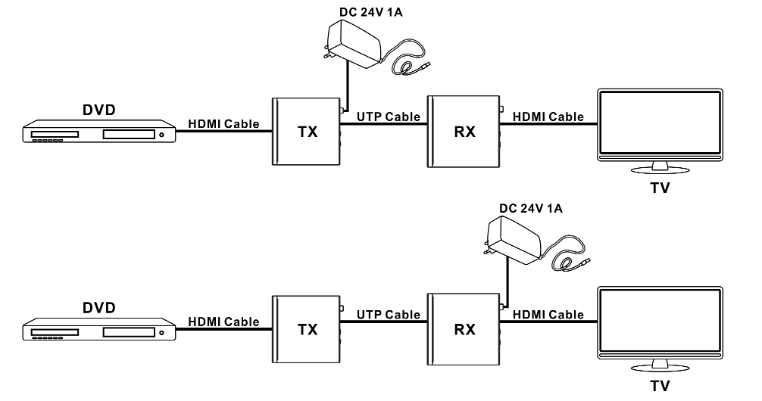
Description 2:
Bi-directional Infrared control example

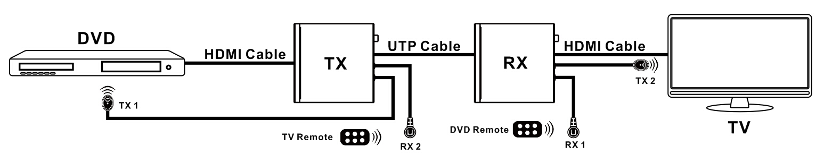

Description 3 Bi-directional RS-232 control example:
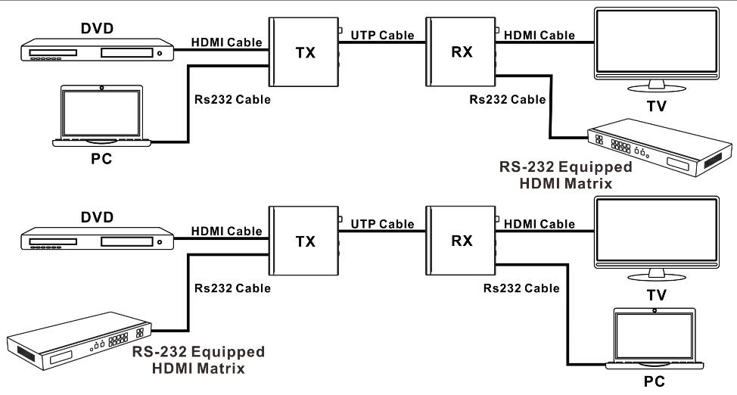

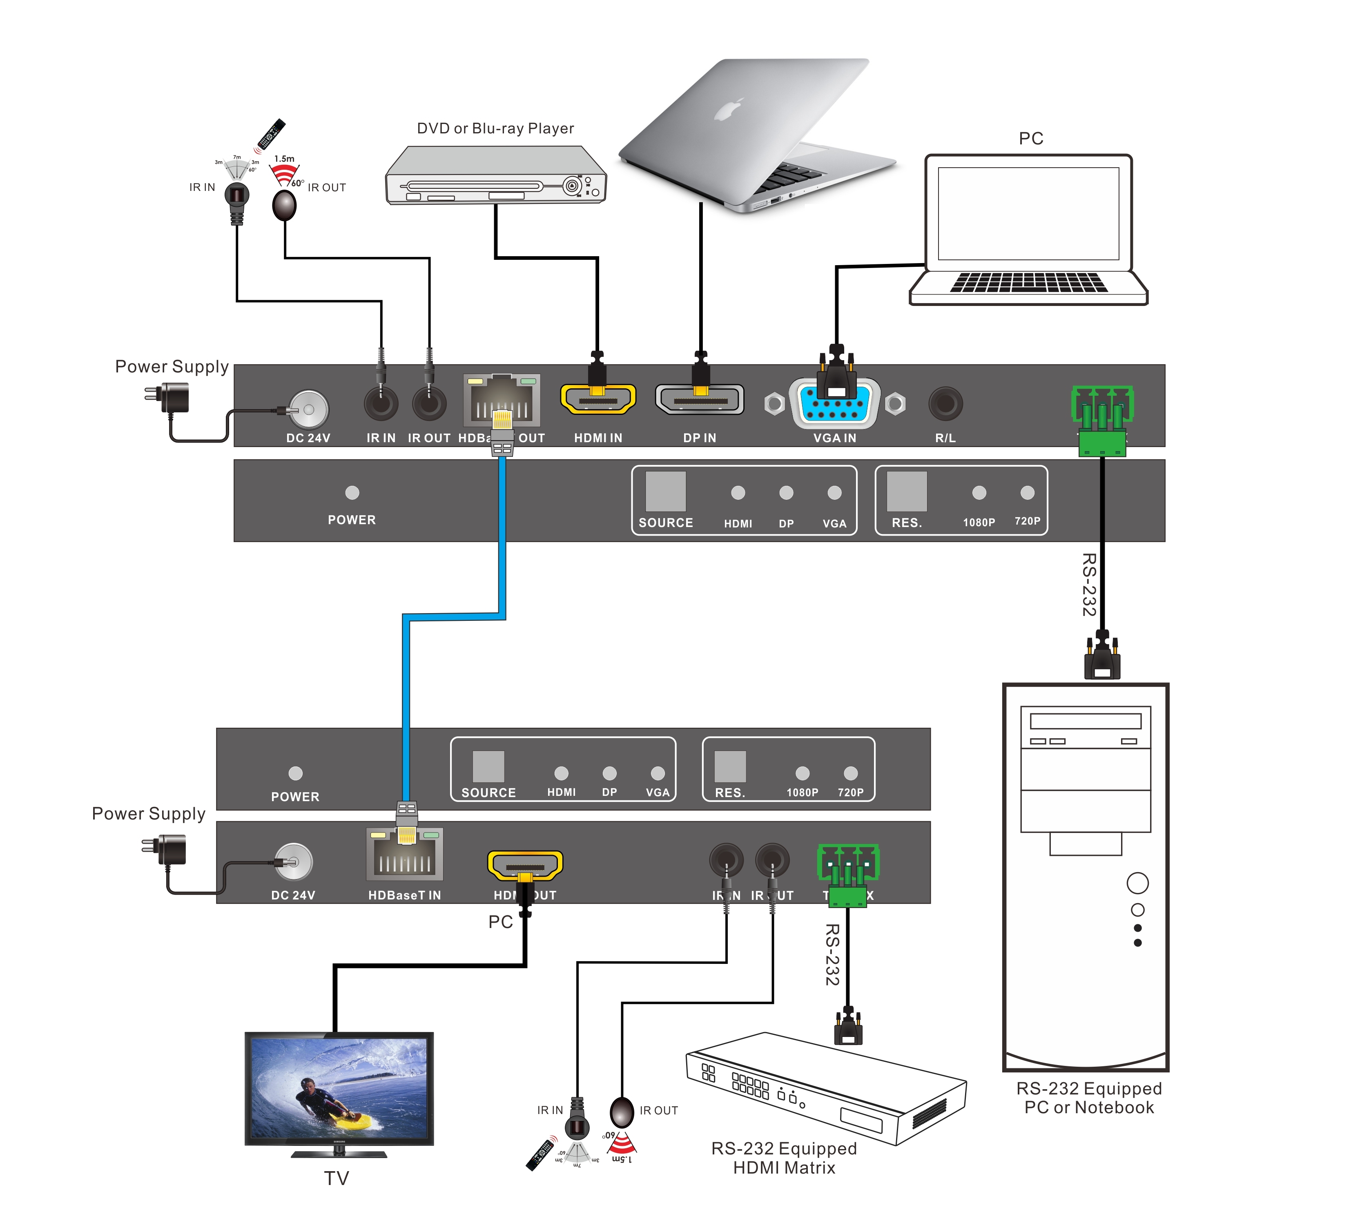
VI. Application Diagram

Switching through software using rs232 port
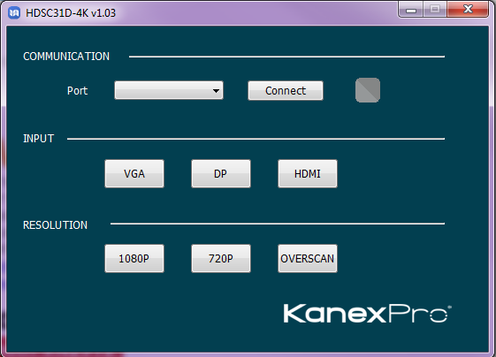

After-sales Service & Warranty Information
If there appear some problems when running this product, please check and consult the user manual for anything that you may have missed.
- Product Limited Warranty: We warrants that its products will be free from defects in materials and workmanship for three years, which starts from the first date of purchase (The purchase invoice shall prevail).
Proof of purchase in the form of a bill of sale or receipted invoice, which is evidence that the unit is within the Warranty period, must be presented to obtain warranty service.

- What’s not covered under the Warranty
(Servicing available for a fee):
- Warranty expiration
- Factory applied serial number has been altered or removed from the product.
- Damage, deterioration or malfunction caused by:
- Normal wear and tear
- Use of supplies or parts not meeting our specifications
- No certificate or invoice as the proof of warranty.
- The product model showed on the warranty card does not match with the model of the product for repairing or had been altered.
- Damage caused by force majeure.
- Unauthorized service
- Any other causes which does not relate to a product defect
- Delivery, installation or labor charges for installation or setup of the product
- Technical Support: Please email to our after-sales department or call us at the number below to inform us the following information about your cases.
- Product version and name.
- Detailed failure situations.
- The formation of the any result
Contact: KanexPro directly at 888-975-1368 or email us at support@kanexpro.com.

Brea, California
KanexPro.com
MPN: HDSC31D-4K

