

4K UHD 1x8 HDMI Splitter
With EDID

User manual

Thank you for purchasing this product. For optimum performance and safety, please read these instructions carefully before connecting, operating or adjusting this product. Please keep this manual for future reference.
I. Introduction
The KanexPro 1×8 HDMI splitter distributes one HDMI source to eight HDMI displays simultaneously. It offers HD video solution for digital signage applications such as shopping malls, HDTV/STB/DVD/Projector /DVR factory, data control center, information distribution, conference room presentation, education and training, corporate showrooms, smart homes and more.
II. Features
- 1 HDMI input signal split to 8 HDMI sink devices.
- HDCP 1.4 protocol compliant.
- 3D HDMI 1.4a video format support.
- 3D video support including Frame packing for all 3D formats up to a 297MHz TMDS clock.
- Support display resolutions up to 4K x 2K@30Hz, 1080P@120Hz,and 1080P 3D@60Hz.
- Support deep color 30bit, 36bit, 48bit per pixel.
- Digital audio format, as DTS-HD/Dolby-true-HD/LPCM 7.1/DTS/Dolby-AC3/DSD.
III. Package
- HDMI Splitter ----------------------------------------------------------------------------- 1PCS
- 5V2A DC Power Supply adapter ------------------------------------------------------- 1PCS
- Operation Manual ------------------------------------------------------------------------- 1PCS
IV. Specifications
- Frequency Bandwidth 2.97Gbps
- HDMI Splitter Input Ports 1 x HDMI Female input port
- HDMI Splitter Output Ports 8 x HDMI Female output ports
- Power Supply DC 5V 2A
- ESD Protection Human Body Model: ± 8kV (air-gap discharge)
± 4kV (contact discharge)
- Dimensions (mm) 118 mm(W) x 250mm(D) x 32mm(H)
- Weight 720g
- Operating Temperature 0°C ~ 40°C / 32°F ~ 104°F
- Storage Temperature -20°C ~ 60°C / -4°F ~ 140°F
- Relative Humidity 20 ~ 90% RH (Non-condensing)
- Power Consumption (Max) 10W

V. Operation controls and Functions
Front Panel
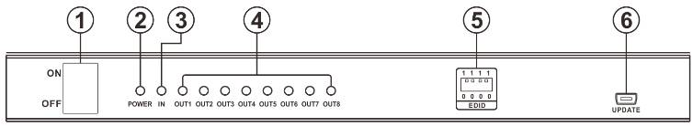
- ON/OFF: Power on/off switch.
- POWER LED: This red LED illuminate when the device is connected with power supply.
- INPUT LED: This red LED illuminate when the HDMI signal plug in.
- OUTPUT LED: These red LED illuminate when the TV plug in corresponding HDMI output
Port.

- EDID Selector: Select HDMI output signal format via EDID Selector.
Position | EDID Description
0 0 0 0 | Copy EDID from HDMI OUT1
0 0 0 1 | 1080p, 2CH AUDIO
0 0 1 0 | 1080p, DOLBY/DTS 5.1
0 0 1 1 | 1080p, HD AUDIO
0 1 0 0 | 1080i, 2CH AUDIO
0 1 0 1 | 1080i, DOLBY/DTS 5.1
0 1 1 0 | 1080i, HD AUDIO
0 1 1 1 | 3D,1080p, 2CH AUDIO
1 0 0 0 | 3D, 1080p,DOLBY/DTS 5.1
1 0 0 1 | 3D,1080p, HD AUDIO
1 0 1 0 | 4Kx2K, 2CH AUDIO
1 0 1 1 | 4Kx2K, DOLBY/DTS 5.1
1 1 0 0 | 4Kx2K, HD AUDIO
1 1 0 1 | 1080p, 2CH AUDIO
1 1 1 0 | 1080p, 2CH AUDIO
1 1 1 1 | Auto Compare HDMI OUT EDID
- UPDATE: System software update.

Rear Panel
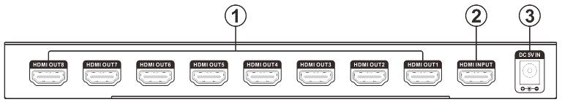
- HDMI OUTPUT: These slots are where you connect the HDTV or monitor with HDMI cable.
- HDMI INPUT: This slot is where you connect the HDMI source output from DVD, PS3.
- DC 5V: Plug the 5V DC power supply into the unit and connect the adapter to AC wall outlet.

VI. Application Example
