

HAECOAX2 - 4K Compliant Audio De-Embedder
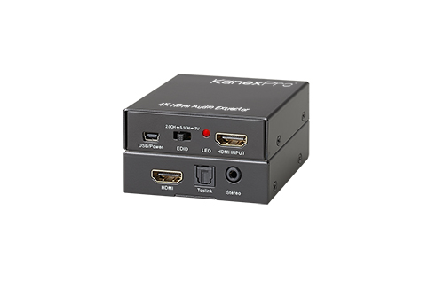
Extract multi-channel audio from HDMI 4K Devices

User manual

Thank you for purchasing this product. For optimum performance and safety, please read these instructions carefully before connecting, operating or adjusting this product. Please keep this manual for future reference.

- Introduction
The KanexPro HAECOAX2 is a 4K compliant audio de-embedder that extracts the audio from HDMI signal and provides outputs for analog stereo using 3.5mm head phone jack and digital TOSLINK audio. It will also De-embed audio with or without HDMI output connected to a display.

  - Features
- HDMI Audio De-embedding – Analog Stereo & TOSLINK digital Audio
- Supports 4K, 1080p/60 and 3D
- De-embeds audio with or without HDMI output connected to a display
- Supports Color depths of 8,10, 12 & 16 bits
- Automatic input cable equalization
- Front panel Micro-USB for power
- Converts 2CH from 24-bit up to 192 kHz audio
- Supports 3D & CEC pass-through
- Supports selectable audio through switching
- HDMI audio output: PCM 2, 5.1, 7.1, Dolby 5.1, DTS 5.1, D-TrueHD, and DTS-HD
- Compliant with HDMI 1.4a, CTS 1.4a, DVI 1.0 & VESA DisplayPort 1.1a standards.

  - Package
1 x HDMI Audio De-embedder
1 x USB Cable (standard to mini)
Operation Manual
  - Specifications
- Frequency/Bandwidth: 2.97Gbps
- Input Ports: 1 x HDMI Female ports.
- Output port: 1 x HDMI Female port, 1x Toslink, 1x 3.5mm stereo jack
- HDMI Audio Output: PCM2, 5.1, 7.1CH, Dolby 5.1, DTS5.1, D-TrueHD, DTS-HD
- Power Supply: Via USB POWER
- ESD Protection: Human Body Model: ± 8kV (air-gap discharge)
± 4kV (contact discharge)
- Dimensions (mm): 60 (D) x 55 (W) x 20 (H)
- Weight (g): 40 (1.4 ounces)
- Operating Temperature: 0˚C ~ 40˚C / 32˚F ~ 104˚F
- Storage Temperature: -20˚C ~ 60˚C / -4˚F ~ 140˚F
  - Operation controls and Functions
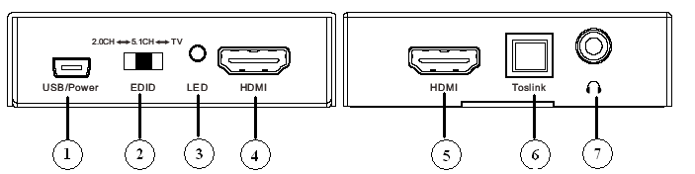
- USB Power: Connect the USB Cable to source USB port for power in.
- EDID Switch: Press this switcher & select the 2.0CH, 5.1CH,TV EDID to source.
- POWER LED: This red LED illuminate when the device is connected with power supply.
- HDMI input: This port is where you connect the HDMI source output from Blu-ray, PS4, Set-top Box or PC/ Laptop.
- HDMI OUT: This port is where you connect the HDTV or monitor with HDMI cable for input source display.
- Toslink OUT: This slot is where you connect to the audio amplifier with optical fiber cable.
- AUDIO OUT: This slot is where you connect to the speaker with 3.5mm earphone cable.
  - Application Example
1. Connect a source such as a Blu-Ray Player, game console, A/V Receiver, Cable or Satellite Receiver, etc. to the audio extractors HDMI input.
2. Connect a display such as a TV or Projector to the HDMI output on the extractor. Connect the Toslink out to digital audio amplifier and stereo out to headphone or analog audio amplifier.
3.Power on the device and display.

Attention: If HDMI source power is not enough, the converter may display a flickering or intermittent dropout that means an external power of 5V, 1 amp will be needed via USB to use the de-embedder. USB to barrel cable is supplied.
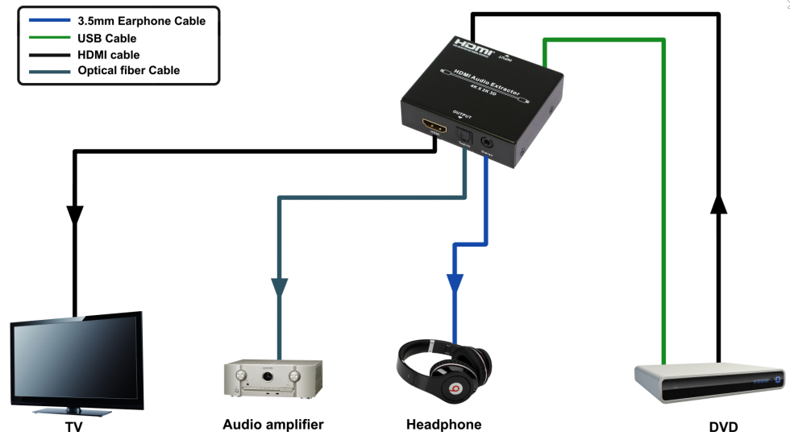
Application Diagram
Warranty
KanexPro® warrants that (a) its products (the “Product”) will perform greatly in agreement with the accompanying written materials for a period of 36 months from the date of receipt (3 years) and (b) that the product will be free from defects in materials and workmanship under normal use and service for a period of 1 year.
Customer Remedies:
KanexPro entire liability and Customer’s exclusive remedy shall be, at KanexPro option, either return of the price paid for the product, or repair or replacement of the Product that does not meet this Limited Warranty and which is returned to KanexPro with a copy of customers’ receipt. This Limited Warranty is void if failure of the Product has resulted from accident, abuse, or misapplication. Any replacement Product will be warranted for the remainder of the original warranty period of 3 years, whichever is longer.

No other warranties:
TO THE MAXIMUM EXTENT PERMITTED BY APPLICABLE LAW, KANEX DISCLAIMS ALL OTHER WARRANTIES, EITHER EXPRESS OR IMPLIED, INCLUDING, BUT NOT LIMITED TO IMPLIED WARRANTIES OF MERCHANTABILITY AND FITNESS FOR A PARTICULAR PURPOSE, WITH REGARD TO THE PRODUCT AND ANY RELATED WRITTEN MATERIALS. THIS LIMITED WARRANTY GIVES CUSTOMERS SPECIFIC LEGAL RIGHTS. CUSTOMERS MAY HAVE OTHER RIGHTS DEPENDING ON THE JURISDICTION.
No Liability for Damages:
TO THE MAXIMUM EXTENT PERMITTED BY APPLICABLE LAW, IN NO EVENT SHALL KANEX BE LIABLE FOR ANY DAMAGES WHATSOEVER (INCLUDING WITHOUT LIMITATION, SPECIAL, INCIDENTAL, CONSEQUENTIAL, OR INDIRECT DAMAGES FOR PERSONAL INJURY, LOSS OF BUSINESS PROFITS, BUSINESS INTERRRUPTION, LOSS OF BUSINESS INFORMATION, OR ANY OTHER PECUNIARY LOSS) ARISING OUT OF THE USE OF OR INABILITY TO USE THIS PRODUCT, EVEN IF KANEX HAS BEEN ADVISED OF THE POSSIBILITY OF SUCH DAMAGES.



Brea, California
Visit: KanexPro.com
MPN: HAECOAX2

